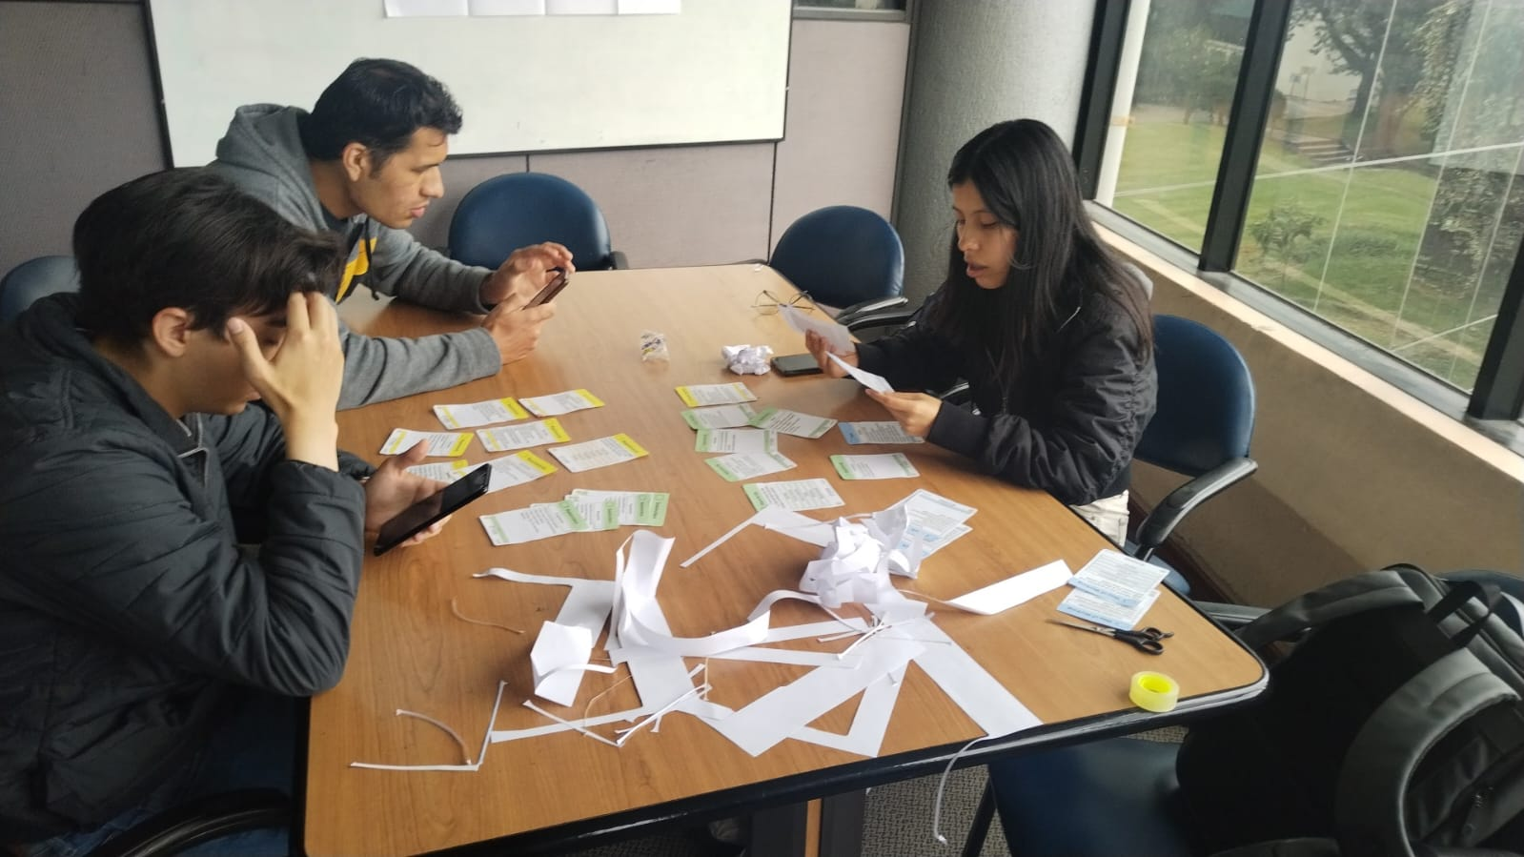

**Link Video:** [**https://youtu.be/5kGjv3JuKWk**](https://youtu.be/5kGjv3JuKWk)